**Zomato Data Manipulation and Reporting using Power BI**

Constructing a consolidated and interactive PowerBI report that will allow Zomato to quickly assess the required data.

**Steps performed:**

**Data transformation steps:**

1. Imported data from all 8 available Excel files into Power BI using get data and transformed data.
2. Renamed all the sheets. Example - KPI to Fact table.
3. Combined all 6 continents tables on row level using Append as new into a single file and renamed it as Zomato Global .
4. Replaced all the wrong City names to correct names.
5. Split the column Restaurant Name, Address to have 2 separate columns respectively using comma as delimiter. Renamed both columns.
6. Removed unwanted columns like Locality and Locality Verbose
7. Created duplicate Zomato global table 2 deleted all columns except Restaurant ID and Cuisines. Used column split on cuisines using delimiter to get 1 cuisine in each row.
8. For Country-Code data removed null or duplicates using remove rows we are left with 15 rows.
9. Disabled the enable load option for separate continent data. Loaded only 4 table in Power BI Desktop.
10. In data model view established relationship between cuisines and Zomato global.

**DAX calculations:**

1. Created a new column for Rating colour. Used the formula as below:

Rating Color = IF('Fact Table'[Aggregate rating] = 0, "Not Rated", IF('Fact Table'[Aggregate rating] <= 2.9 , "Red", IF('Fact Table'[Aggregate rating] <= 3.4 , "Orange" , IF('Fact Table'[Aggregate rating] <= 3.9 , "Yellow" , IF('Fact Table'[Aggregate rating] <= 4.4 , "Green" , IF('Fact Table'[Aggregate rating] <= 5 , "Dark Green", "Other"))))) Created Measures for – Restaurant Count, Average Rating, Average cost, Cuisine count.

1. Creating new measures as below:

Restaurant count in Zomato global table

Average cost in Fact table

Average rating in Fact table

Cuisine count in Cuisines table using distinct count

Created continent column in country code and mapped all country codes using Switch function.

Continent = SWITCH('Country Code'[Country Code], 189, "Africa",215, "Europe", 37, "NAM", 216, "NAM", 30, "SAM", 14, "Oceania", 148, "Oceania", "Asia")

**Created following visuals for the report:**

Worldwide Analysis Page:

1. Created Cards for: a. Cuisine count b.Restaurant Count c. Average Rating d. Average Cost
2. Created 4 slicers Continent, Country, City and Rating colour.
3. Created Map using the Continent -> Country -> City hierarchy, with bubble size indicating the restaurant count.

**Restaurant Performance Analysis Page:**

1. Slicers created for Continent, Country , City ,Has online delivery and Has Table Booking
2. Created Table for Restaurants with average ratings and cuisine count.
3. Created donut chart for Ratings

**Visualization:**

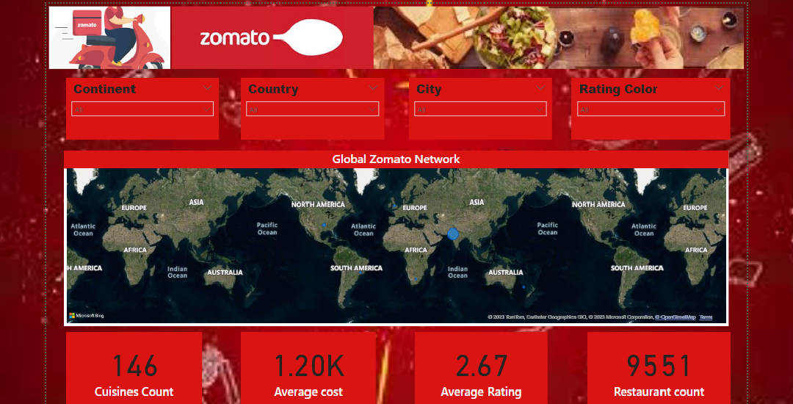

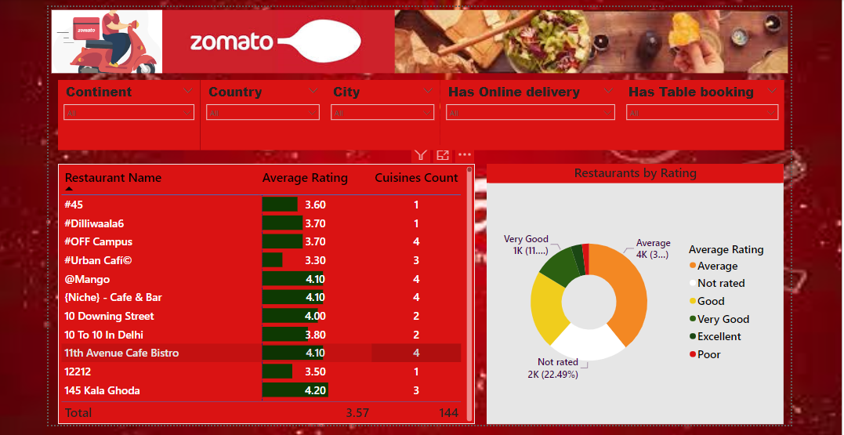

Mobile View Worldwide

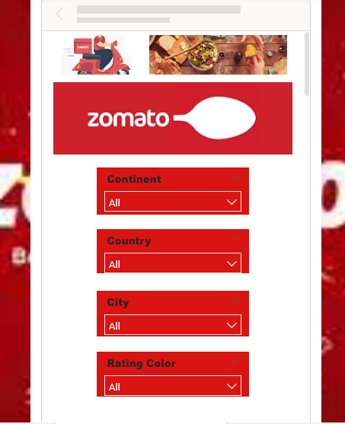 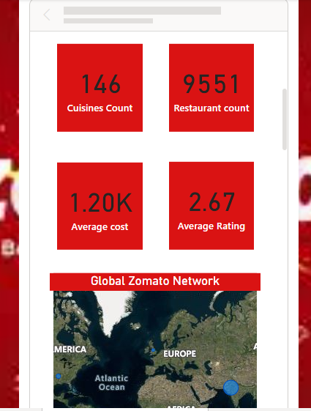

Mobile View Restaurant performance analysis:

